**Proposal for Implementing a Warehouse Management System (WMS)**

**Group – W**



**Foundations of information systems  
 22.2 batch**

**Content**

1. Introduction

2. Problem Statement

3. Proposed Solution

4. Key Features of the WMS System

5. Implementation Plan

6. Expected Benefits

7. Challenges

8. Conclusion

9. Proofs



**Orange Electric Sri Lanka**



**Address of Orange Electric Factory**

Orange Electric Factory,

Meegoda Rd,

Sri Lanka.



1. **Introduction**

Orange Electric is a brand of OREL CORPORATION PVT LTD. It is a multinational company that was founded on six continents with the goal of supplying light and energy to people all over the world. It is the force that strives to supply uplifting energy so that people can make positive changes everywhere.

Energy evolved along with the world, and Orange Electric was no exception. The company began by making incandescent light bulbs and electrical accessories. Today, it offers solar power, modular switches and sockets, low voltage switchgear, wiring, batteries, household appliances, power generators, elevators, and energy-saving lighting solutions.

Customer service is essential in today's fast-paced business environment for influencing consumer views, building brand loyalty, and propelling company expansion. At Orange Company, we understand that maintaining a competitive advantage and sustaining long-term success depend critically on providing excellent client experiences. Nevertheless, we have discovered some serious issues with our present customer care procedures as we work to satisfy the changing demands and expectations of our clients.

This proposal outlines a solution to address the challenges faced in managing internal product delivery through the implementation of a Warehouse Management System (WMS).



**2.Problem Statement**

The problem that we got to know through the industrial visit is that the products manufactured by that company are taken to another store and delivered to the required places. For that they have to pay additional transport costs as well as employee wages.

Therefore, they want to do the same procedure within the company itself.

Orange Electric Company faces several challenges in managing its internal product delivery process:

* High Transportation Costs: As a result of the practice of moving products to another store before internal delivery, a sizeable amount of the company's budget is devoted to transportation costs. This redundant step increases costs unnecessarily.
* Extra Employee Salary Costs: The requirement for internal product transportation results in higher employee salary costs related to transportation responsibilities. These expenses go toward the total overhead of operations.
* Absence of Real-time Visibility: Inefficient delivery routing arises from a lack of real-time visibility into internal product movements. In the absence of precise and current product position data, the organization finds it difficult to optimize delivery routes, which results in delays and inefficient use of resources.

**3.** **Proposed Solution**

We propose Orange Electric Company adopt a Warehouse Management System (WMS) designed specifically for internal product distribution. The Warehouse Management System will provide a centralized platform to streamline operations, reduce costs, and improve efficiency in managing internal product delivery.

**4.Key Features of the Warehouse Management System (WMS)**

1. Real-time Inventory Tracking: The WMS will make it possible to track inventory in real-time on business property, guaranteeing precise and current data on product locations and amounts.
2. Order Processing and Routing: For internal product deliveries, an intuitive interface will make order processing and routing easier. Workers can enter the destination inside the company's boundaries while creating delivery orders in the system. By using real-time data to improve delivery routes, the WMS will save transportation expenses and boost delivery effectiveness.
3. Mobile App for Delivery Workers: To enable delivery workers to receive and update delivery orders while on the road, a mobile application will be created. By facilitating real-time status updates and enhancing communication, this feature will increase delivery efficiency and accuracy overall.
4. Integration with Current Systems: The WMS will easily interface with the inventory and order management systems that are currently in place, guaranteeing uninterrupted data flow and little interference with ongoing operations.

By implementing the proposed WMS, Orange Electric Company will be able to overcome the challenges associated with internal product delivery and achieve greater efficiency and cost savings in its operations.

**5.Implementation Plan**

|  |  |  |
| --- | --- | --- |
| **Task** | **Sub Tasks** | **Weeks** |
| Requirements Gathering | Conduct stakeholder meetings to gather requirements | 2 |
| Define system specifications and functionalities | 1 |
| Development | Develop and customize the Warehouse Management System | 3 |
| Integrate with existing systems and databases | 2 |
| Testing | Conduct comprehensive testing of the WMS to ensure functionality and reliability | 2 |
| Address any issues or bugs identified during testing | 1 1/2 |
| Training and Deployment | Provide training to employees on how to use the WMS | 2 |
| Deploy the WMS across all company locations. | 2 |

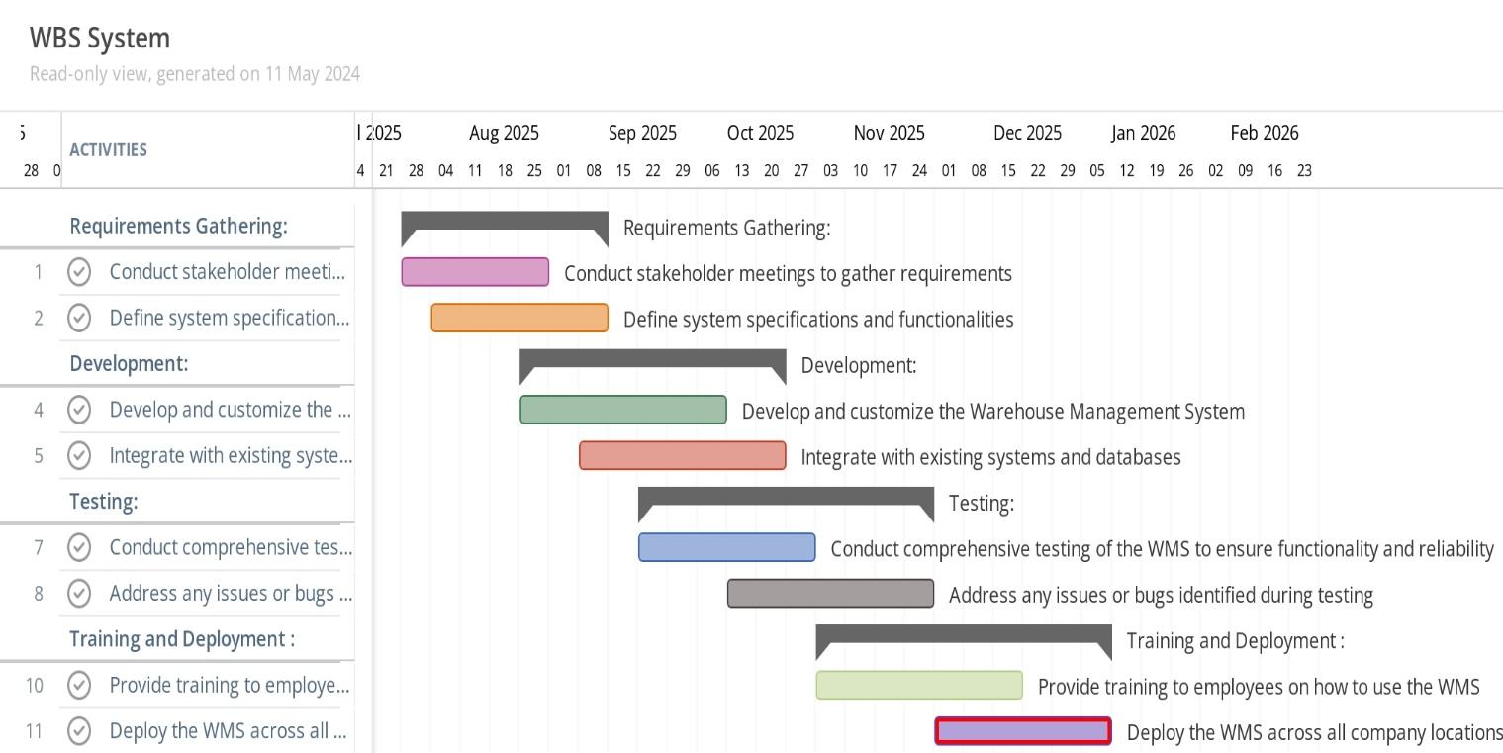

**6.Expected Benefits**

The advantages Orange Electric Company will get from implementing the Warehouse Management System (WMS). Below is a quick breakdown of every advantage.

Cost Reduction:

* Transportation: The WMS's optimized delivery route can result in a sizable decrease in transportation expenses.
* Employee compensation Costs: Reducing the additional employee compensation related to transportation obligations can be achieved by doing away with the necessity for outside transportation.

Increased Productivity:

* Streamlined Operations: By cutting down on delays and optimizing internal product delivery procedures, the WMS raises overall productivity.
* Real-time Visibility: Better decision-making results in more effective resource allocation and delivery routing when inventory and product movements are tracked in real-time.

Improved Customer Satisfaction:

* Prompt Delivery: Orange Electric Company can guarantee prompt and precise product delivery to clients, increasing their happiness, with enhanced delivery procedures and real-time tracking.

Scalability and Adaptability:

* The WMS offers flexibility and long-term advantages by growing with the business and adapting to shifting demands.

**7.Challenges**

Here are the challenges of implementing the Warehouse Management System (WMS) for Orange Electric Company.

Expenses of Implementation:

* For the business, the initial outlay for hardware acquisition, software development, and training could be expensive.

Complexity of Integration:

* To ensure smooth data flow and no interruption to ongoing operations, integrating the WMS with the inventory and order management systems that are currently in place may be complicated and need careful design.

Employee Resistance:

* It might be difficult to get staff members to accept new technologies and alter established procedures. To lessen this resistance, effective change management techniques and training are crucial.

Technical Problems:

* During the deployment and integration process, technical problems like software defects, system outages, or compatibility difficulties could surface and possibly disrupt operations.

Maintain And Support:

* Devoted resources and specialized knowledge are needed for the WMS's ongoing maintenance and support. To maintain the system's functionality, frequent upgrades, troubleshooting, and technical assistance are necessary.

Data Security Issues:

* Data security and privacy issues may arise when sensitive inventory and delivery data is stored and managed within the WMS. Securing firm data requires putting strong security measures in place.

**8. Conclusion**

In conclusion, Orange Electric Company has a strategic chance to solve current issues and improve operational effectiveness by putting in place a Warehouse Management System (WMS) designed specifically for internal product delivery. The suggested WMS provides substantial advantages for the business by optimizing internal product delivery procedures, cutting down on transportation expenses, and enhancing real-time insight into inventory movements.

Despite the potential challenges associated with implementation, such as initial costs, integration complexity, and employee resistance, the long-term advantages of the WMS outweigh these hurdles. Through proper planning, effective change management strategies, and ongoing support, Orange Electric Company can successfully overcome these challenges and realize the full potential of the WMS.

**9. Proofs**

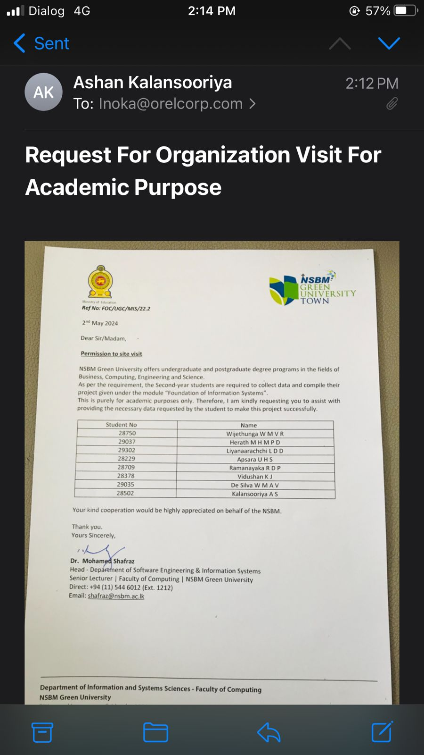

**Group Members**

|  |  |
| --- | --- |
| **Name** | **Index No** |
| Herath M.H.M.P.D | 29037 |
| Liyanaarachchi L.D.D | 29302 |
| Kalansooriya A.S | 28502 |
| De Silva W.M.A.V | 29035 |
| Vidushan K.J | 28378 |
| Apsara U.H.S | 28229 |
| Wijethunga W.M.V.R | 28750 |
| Ramanayaka R.D.P | 28709 |

**…..THANKYOU…..**